3. DIGITAL SIGNATURE – RSA
Aim
To implement a digital signature using RSA in Python and verify the authenticity of the message.
Algorithm
- Import RSA, padding, and hashing modules.
- Generate an RSA private key.
- Generate the corresponding public key.
- Read the message from the user.
- Create a digital signature using the private key.
- Display the generated signature.
- Verify the signature using the public key.
- Display whether the verification is successful or failed.
Program
import hashlib
import math
p = 61
q = 53
n = p * q
phi = (p - 1) * (q - 1)
e = 17
d = pow(e, -1, phi)
message = input("Enter the message: ")
hash_value = hashlib.sha256(message.encode()).hexdigest()
hash_int = int(hash_value, 16) % n
signature = pow(hash_int, d, n)
print("Original Message:", message)
print("SHA-256 Hash:", hash_value)
print("Digital Signature:", signature)
verified_hash = pow(signature, e, n)

if verified_hash == hash_int:
print("Signature Verification: SUCCESS")
else:
print("Signature Verification: FAILED")Output:
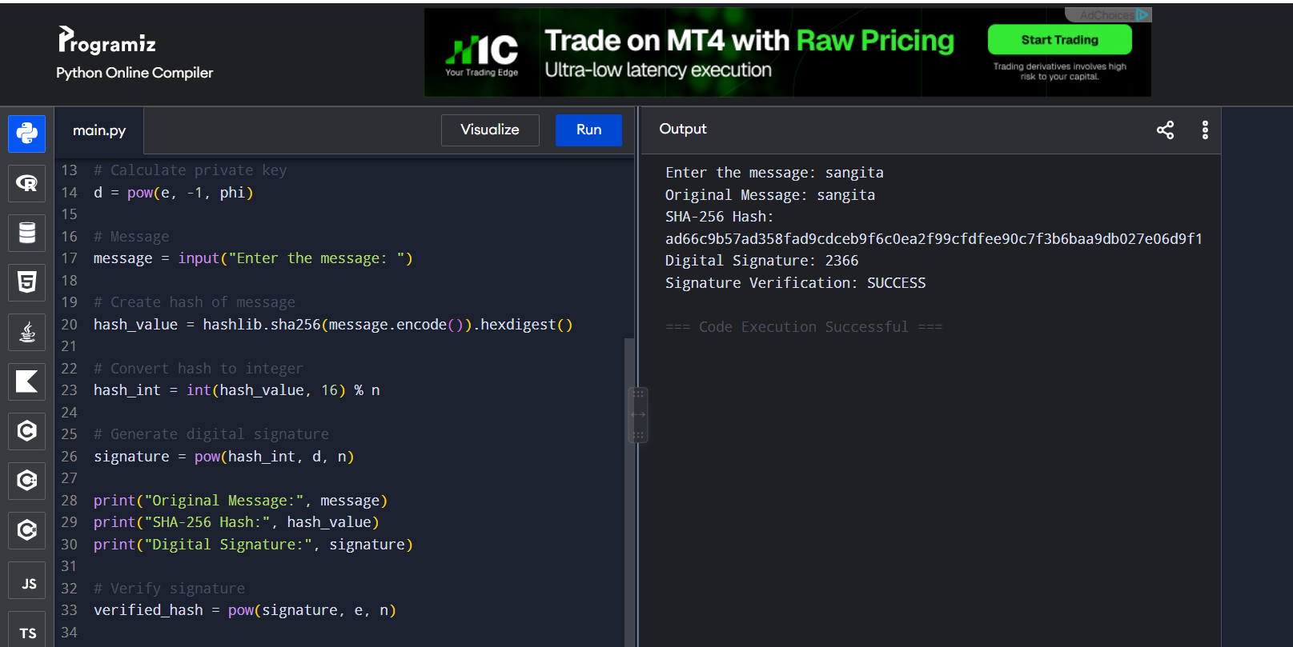
Result
The RSA digital signature was successfully generated and verified using the public key.

